# Overview

* Given our stats we were predicted to finish with 11.6 Points - We finished with 10 in the Big West.
* **Passing accuracy in the back is 8% less than passing accuracy in the midfield**
* Majority of misplayed passes come from our defensive third. This could be a huge area for improvement that could increase effectiveness in play.
* McGee (22) and Quinn (17) have been the most effective at getting balls into the box successfully
* **Losing too many defensive duels around the top of our box - 10% lower than win rate in the midfield**
* We lacked offensive duels around our opponents box/struggled to take players on. Right side was extremely lacking and only had 12-15 duels the whole season.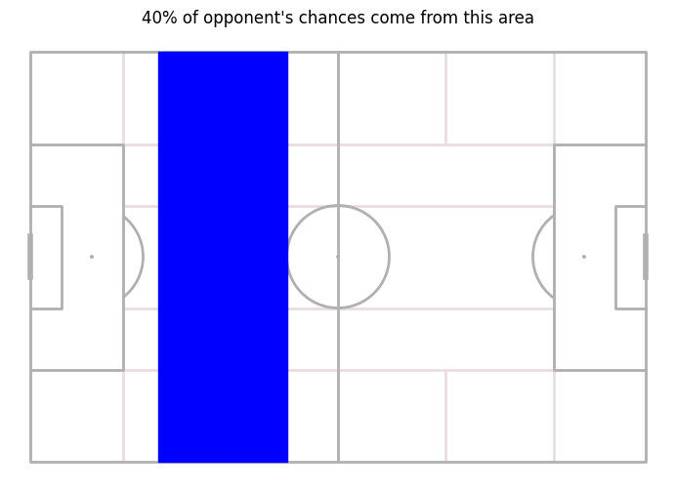
* 42% of our opponents chances came off mistakes (Tackle/Misplayed Pass)
* **48% of our opponents goals came off mistakes**
* Majority of chances originate from the border of 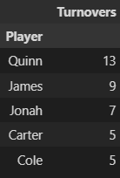defensive and middle third (40%).
* Quinn had by far the most mistakes that led to opponent’s shots (Only Big West Games)
* 19% of their shots come directly off of our misplayed pass or tackle without even passing the ball
* 29% of their shot assists that resulted in a goal came off of our misplayed pass or tackle without even passing the ball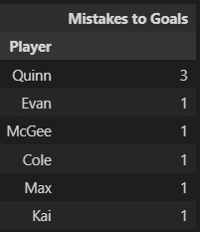

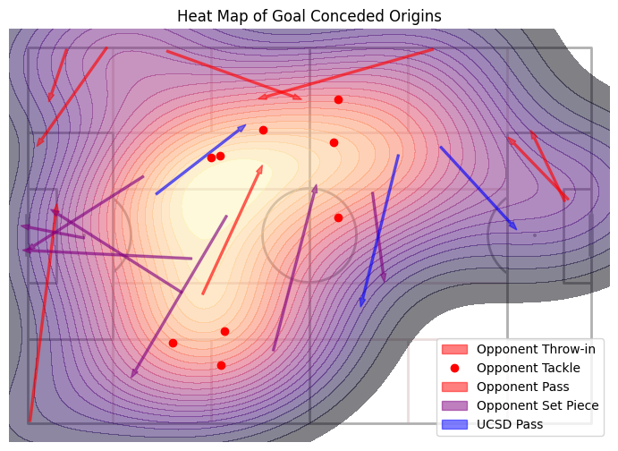

# League Comparison

## Team Comparisons

8th in goals conceded avg

8th in goals scored avg

8th in touches in penalty area avg

6th in shots against on target avg

10th in shots on target avg

9th in xCG - CG

7th in passes per game avg

7th in passing accuracy

2nd in forward passes percentage (percent of passes that are forward)

6th in defensive duels accuracy

5th in offensive duels accuracy

10th in deep completed passes avg

5th in deep completed crosses avg

9th in dangerous passes avg (passes + crosses)

3rd in crossing accuracy

7th in losses per game avg

7th in passes per loss

## Player Comparisons

* Most of our strikers struggled to win their offensive duels
* Our strikers pass accuracies tend to be on the higher side in the league
* Our strikers struggle to get a lot of shots on target compared to other strikers
* A few of our strikers struggled to get involved in play and had low touches per min they played

### Midfield

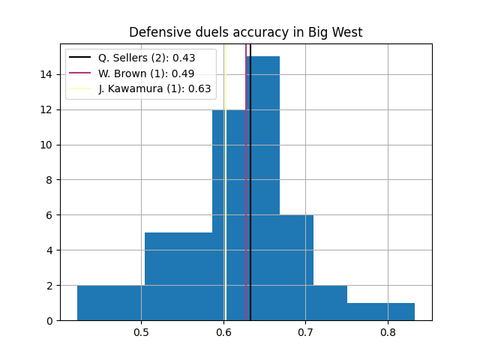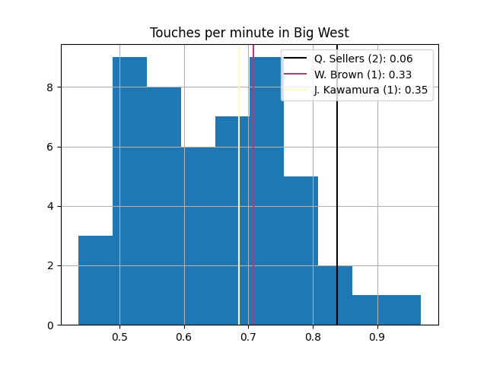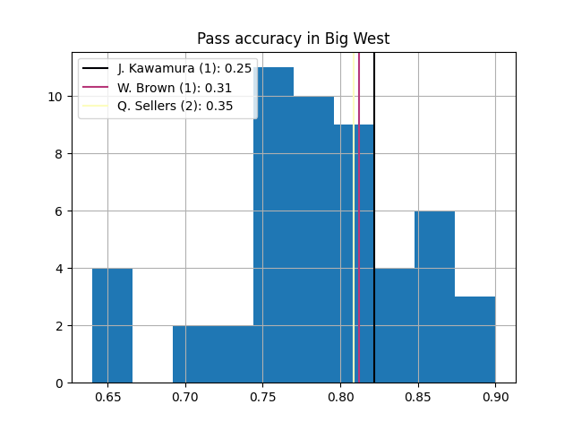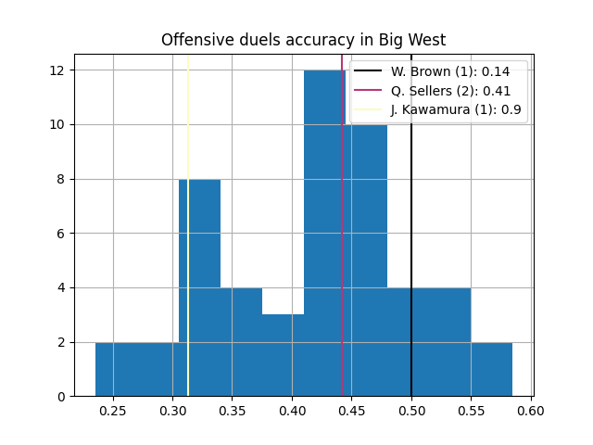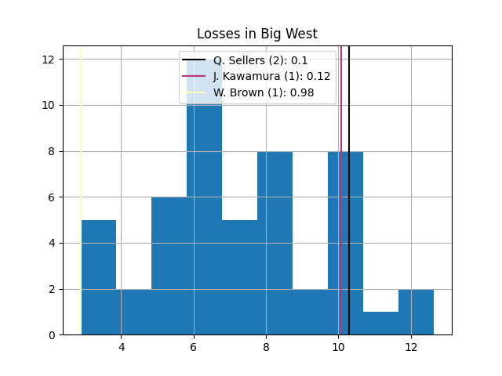

* All of our statistics for our midfielders tend to be around average.
* Midfield players tend to have more losses compared to other midfielders

### Defense

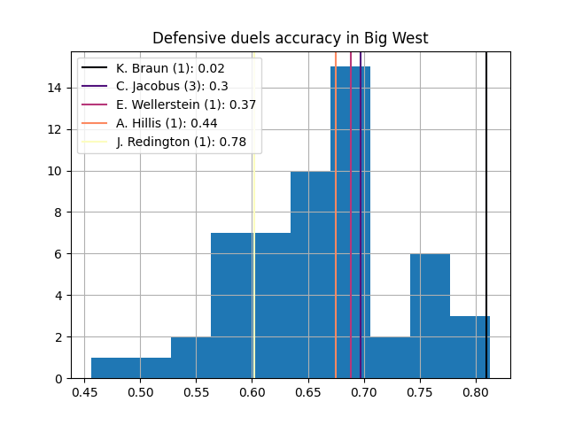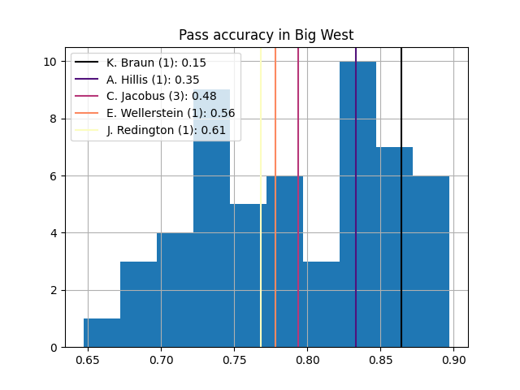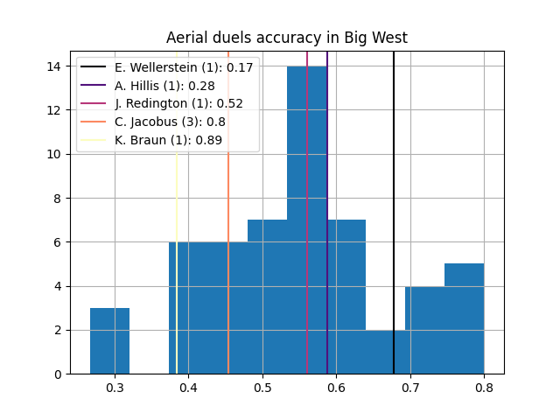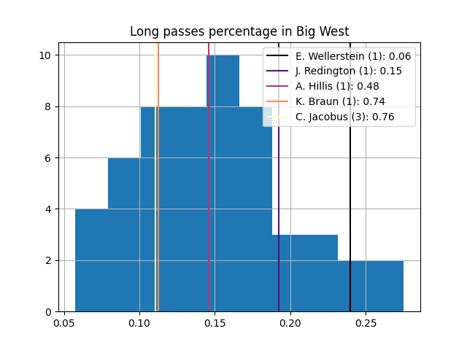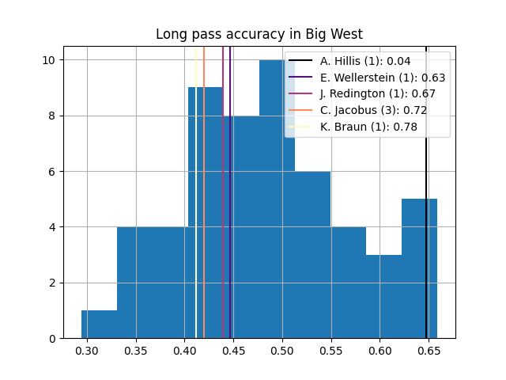

* Keenai has one of the best ground defensive duels rate but one of the worst aerial duel win rate
* Adam had a very high long ball accuracy but the rest of our defenders struggled to connect long balls
* Evan goes long more than most defenders in the big west
* Defenders pass accuracies are around average

# Passing

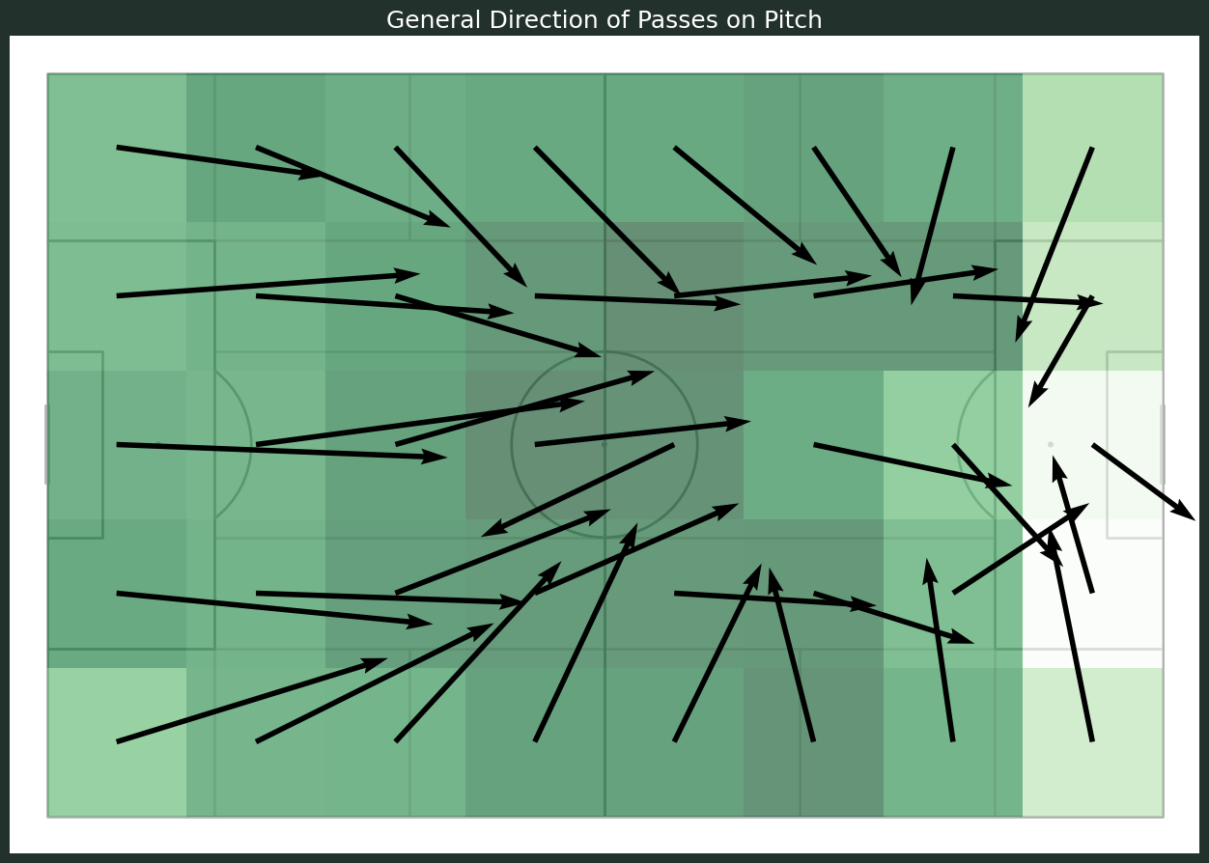

* Majority of passes in the middle third of the field
* Lack of passes/crosses from the right flank compared to the left
* Passes in the center of the midfield tend to go directly forward. These are the passes that tend to drop in accuracy looking at the graphs below

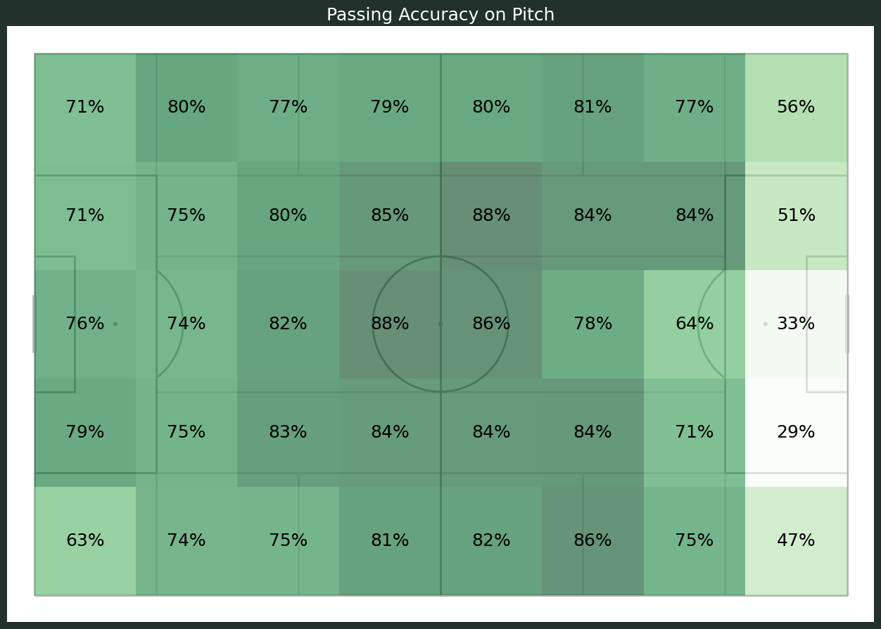

* The passing accuracy in our defensive third is relatively low. However, to what might be expected majority of the missed passes are short passes within the third or passes into mid third not long balls.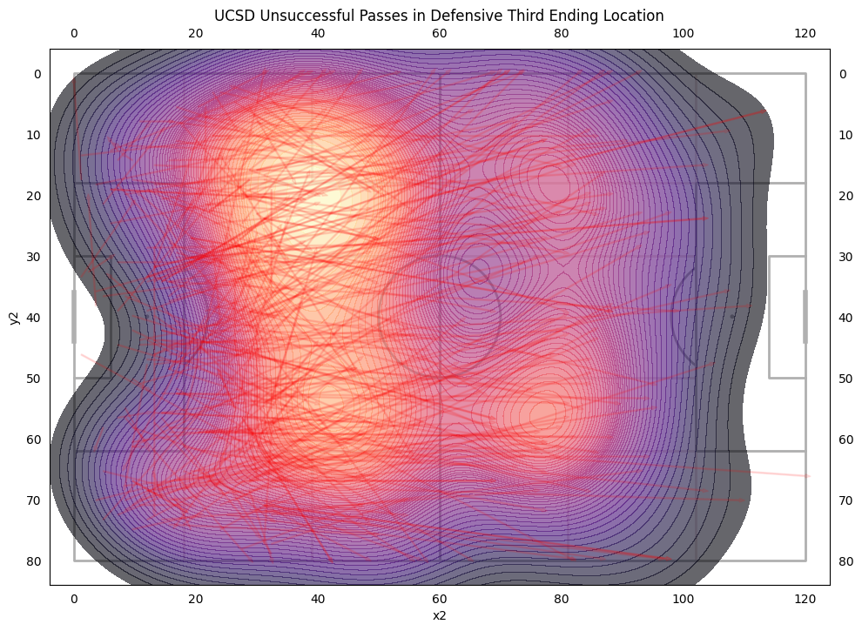
* Passing accuracy in the midfield is pretty good.
* Passing accuracy drops off significantly into the attacking third.
* Passing into the center of attacking third accuracy is very low.

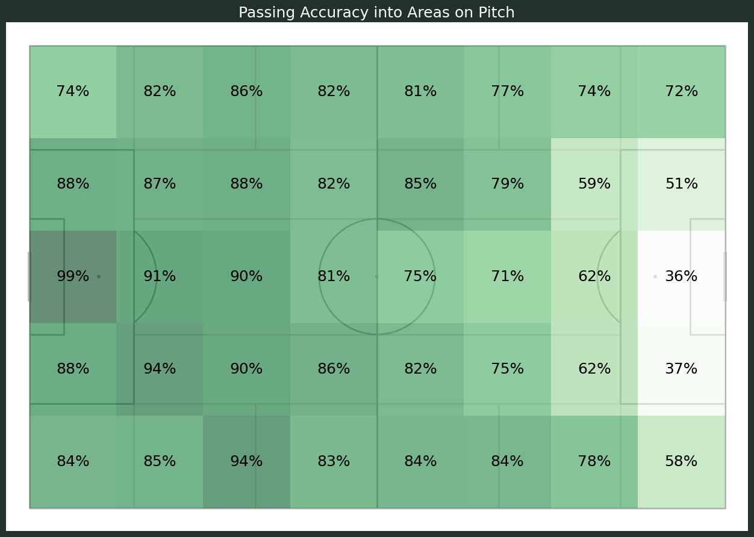

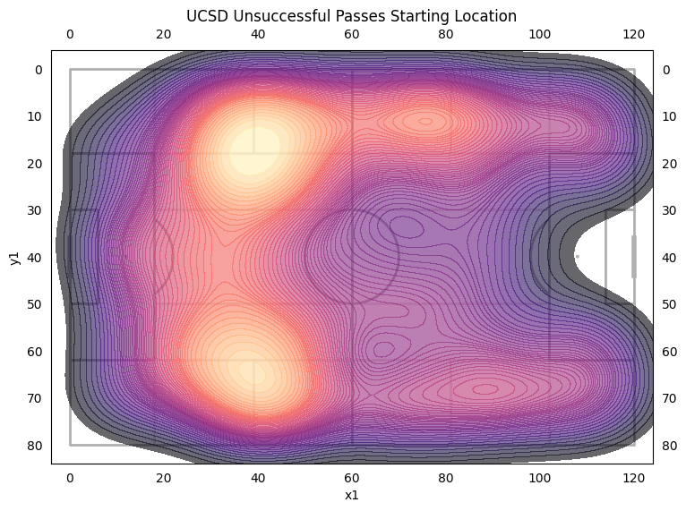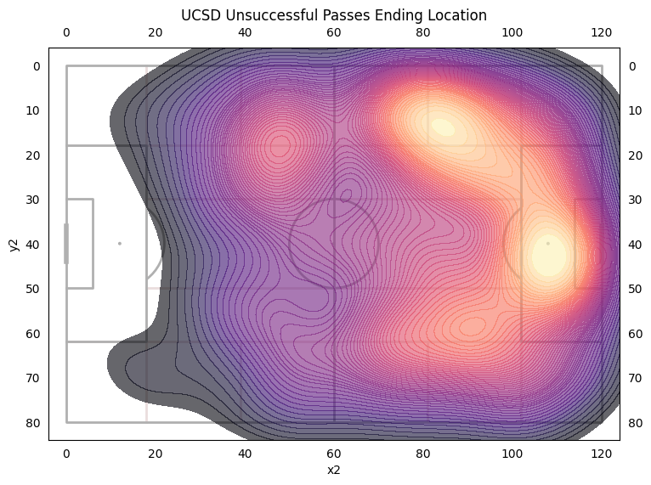

* Majority of misplayed passes come from our defensive third. This could be a huge area for improvement that could increase effectiveness in play.
* Most misplayed passes are into and around the top of the box as well as longer balls into the flanks.

# 

# 

# 

# 

# 

* Most of the key passes are crosses into the box
* Majority of our deep passes are coming from the left flank.
* McGee and Quinn have been huge in creating chances.
* James had a high amount of key passes for a defender.
* Carter had a huge impact in playing penetrating balls for a defender.

# Defensive Duels

* Need to lose less duels around the corners of the box. 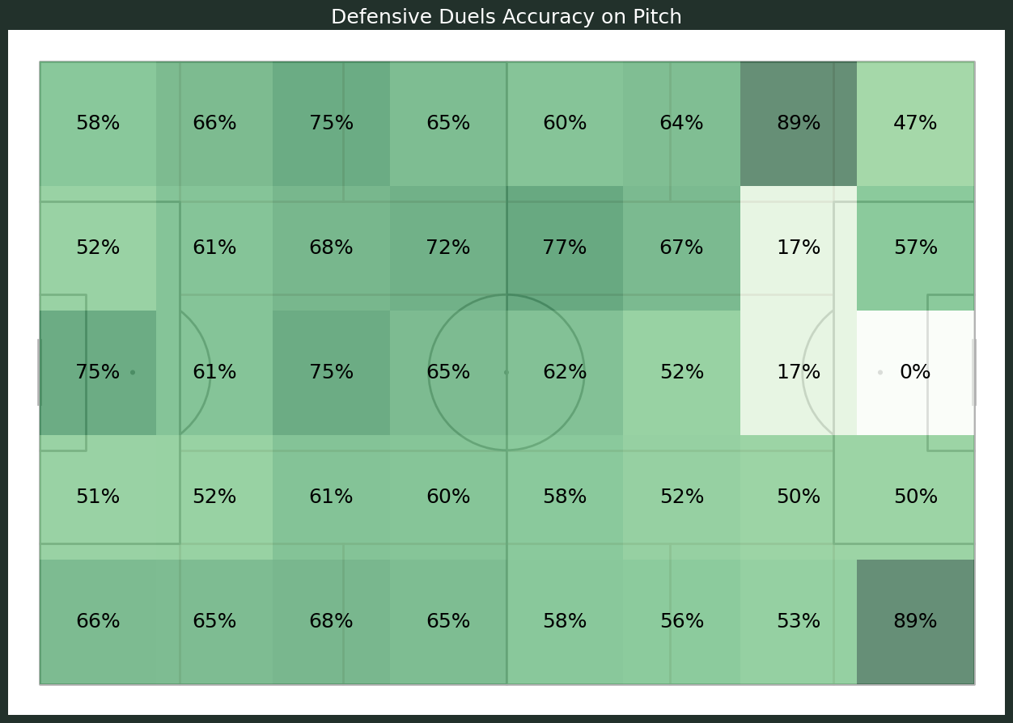
* That's where most of our opponents' chances come through and we are least successful.
* Games where we were able to lose our defensive duels higher on the pitch our opponents had less chances.



# 

# Offensive Duels

* Not a lot of offensive duels around the opponents box.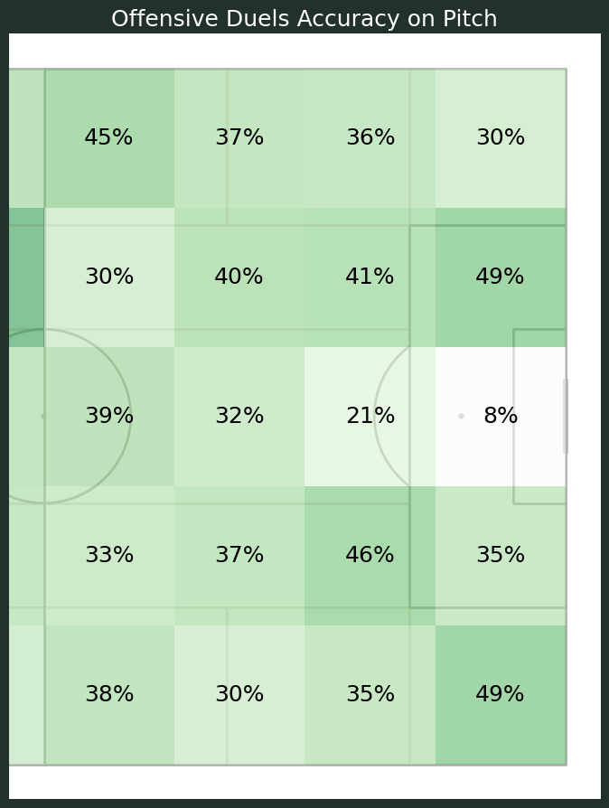
* Offensive duels accuracy in the center of the field is very low.
* Right flank did not take on as many players as the left flank. 15% difference.

# 

# Opportunities Conceded

### Origins

* The middle third in our defensive half was where most of their chances started.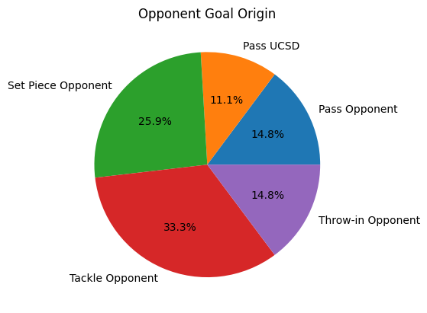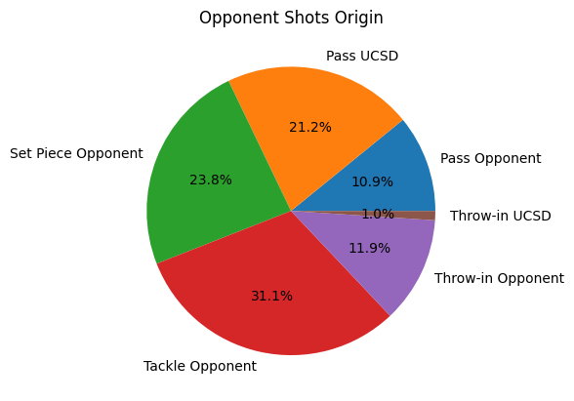

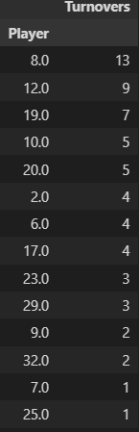

### Shot Assists

* 19% of their shots come directly off of our misplayed pass or tackle without even passing the ball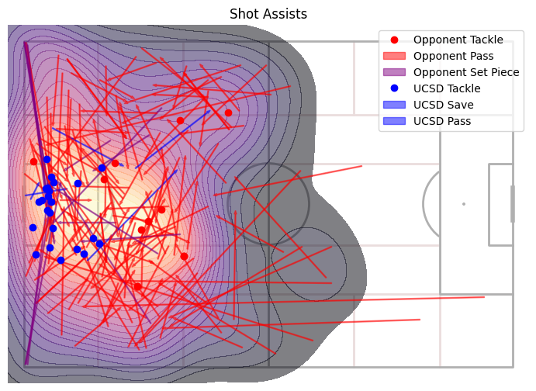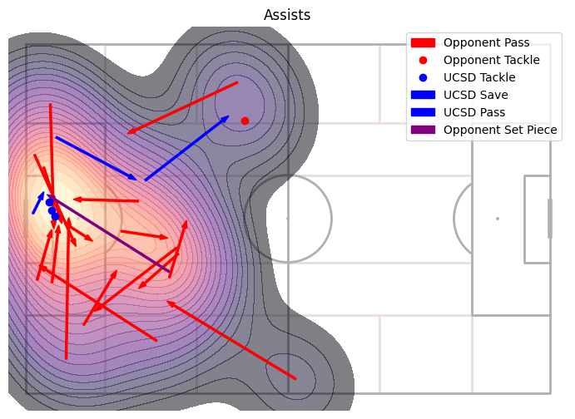
* 29% of their shot assists that resulted in a goal came off of our misplayed pass or tackle without even passing the ball